Name : Abdul Rehman Section :B

Course : AI&ES Roll No : CT-22052

=====================================================================

**Explain the difference between stemming and lemmatization.**

• **Stemming:** It is a process of reducing words to their base or root form by removing prefixes and suffixes. For example, "running" becomes "run", and "better" becomes "better" (although "better" itself is not a root form, stemming might reduce it to "good" or another form).

• **Lemmatization:** This is the process of reducing a word to its dictionary form (lemma) based on its meaning. Lemmatization considers the context and part of speech, unlike stemming. For example, "running" becomes "run", and "better" becomes "good".

**What is sentiment analysis?**

Sentiment analysis is the process of determining the emotional tone behind a series of words. This is used to understand the sentiments expressed in text data, which can be positive, negative, or neutral. Sentiment analysis is commonly applied in social media monitoring, customer feedback, and review aggregation to understand public sentiment towards a product, service, or entity.

**Write a program to perform Character and Subword Tokenization.**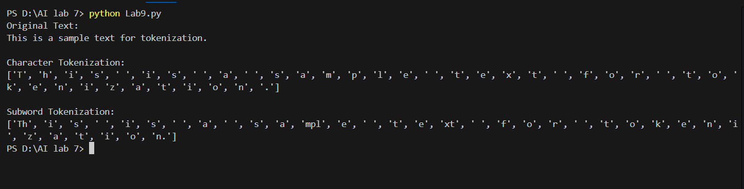

**Write down the Steps for Sentiment Analysis.**

**Steps for Sentiment Analysis**: To perform sentiment analysis, the steps generally include:

* **Text Preprocessing**: Clean the text (remove punctuation, lowercase, remove stop words).
* **Tokenization**: Break the text into smaller units (words or sentences).
* **Feature Extraction**: Convert tokens into features (e.g., using bag-of-words, TF-IDF, or word embeddings).
* **Model Training**: Train a machine learning model (e.g., Naive Bayes, SVM, or neural networks) using labeled data.
* **Prediction**: Use the trained model to predict the sentiment of new text.
* **Evaluation**: Assess the model's performance using metrics like accuracy, precision, recall, and F1 score.

**Create a simple conversational agents to interact with users.**

